**1. What are the two values of the Boolean data type? How do you write them?**

Ans: It is true and false. It is written as True and False.

For example:

x = True

y = False

**2. What are the three different types of Boolean operators?**

Ans: The three types of Boolean operators are: and, or, not.

**3. Make a list of each Boolean operator's truth tables (i.e. every possible combination of Boolean values for the operator and what it evaluate).**

Ans:

|  |  |  |  |  |  |
| --- | --- | --- | --- | --- | --- |
| A | B | A and B | A or B | not A | not B |
| TRUE | TRUE | TRUE | TRUE | FALSE | FALSE |
| TRUE | FALSE | FALSE | TRUE | FALSE | TRUE |
| FALSE | FALSE | FALSE | FALSE | TRUE | TRUE |
| FALSE | TRUE | FALSE | TRUE | TRUE | FALSE |

**4. What are the values of the following expressions?**

(5 > 4) and (3 == 5): False

not (5 > 4) : False

(5 > 4) or (3 == 5): True

not ((5 > 4) or (3 == 5)): False

(True and True) and (True == False): False

(not False) or (not True): True

**5. What are the six comparison operators?**

Ans : > , < , >= , <= , == , !=

**6. How do you tell the difference between the equal to and assignment operators? Describe a condition and when you would use one.**

Ans: == is the equal to operator that is used for comparison, whereas the = is the assignment operator used for assigning a particular value to a variable. For example:

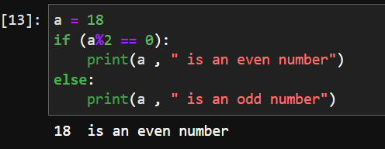

Here a = 18 is the assignment operator whereas a%2 == 0 is a comparison operator.

**7. Identify the three blocks in this code:**

**spam = 0**

**if spam == 10:**

**print('eggs')**

**if spam > 5:**

**print('bacon')**

**else:**

**print('ham')**

**print('spam')**

**print('spam')**

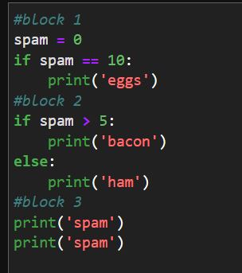

**8. Write code that prints Hello if 1 is stored in spam, prints Howdy if 2 is stored in spam, and prints Greetings! if anything else is stored in spam.**

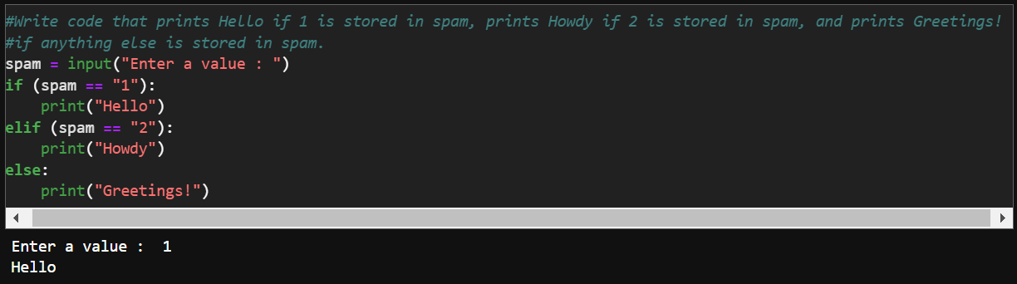

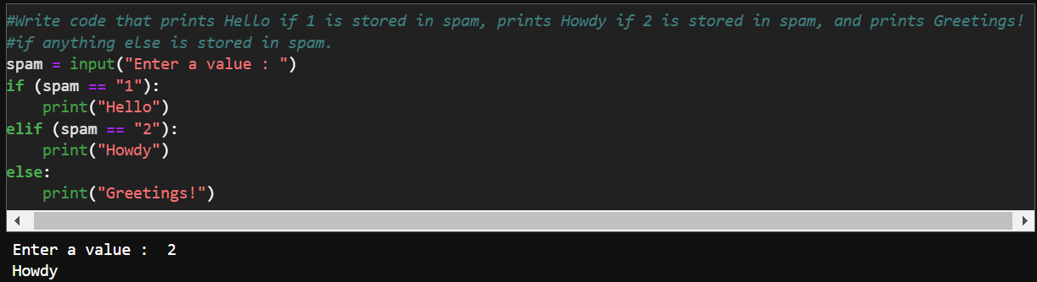

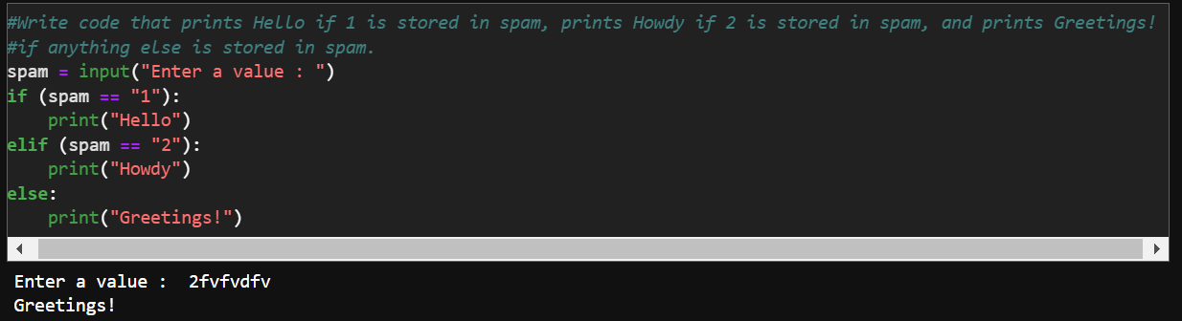

**9. If your programme is stuck in an endless loop, what keys you’ll press?**

Ans: Ctrl-C

**10. How can you tell the difference between break and continue?**

Ans: Break makes the program go out of the loop entirely whereas continue is used to skip the ongoing iteration and execute the next iteration of the loop.

**11. In a for loop, what is the difference between range(10), range(0, 10), and range(0, 10, 1)?**

Ans : They are all the same but they progressively specify the starting number and the amount of iteration. In range(10) the default is assumed to start from 0 and go on to 9 (since 10-1=9) and increase with 1 in each step. Thus here only the end value is specified. In range(0,10) the starting and the end values are mentioned but the iteration is taken to be default as 1. Finally in range(0,10,1) no default values are used as the starting and end value is mentioned along with the necessary step of iteration.

**12. Write a short program that prints the numbers 1 to 10 using a for loop. Then write an equivalent program that prints the numbers 1 to 10 using a while loop.**

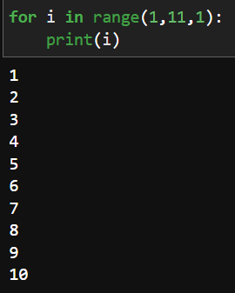 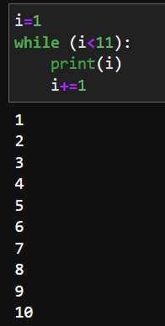

**13. If you had a function named bacon() inside a module named spam, how would you call it after importing spam?**

Ans: from spam import bacon